Waverley School
Summer Newsletter April 2023
Message from the Headteacher I am not really sure where the time has gone but we have arrived in the final term of the year! I usually remind parents and carers to send in hats and sunscreen in this newsletter. With the weather as it is you may need to continue to also send in warm coats and woolly hats! Summer term parents evening is on 5th July. You will be sent details nearer the date and the opportunity to book in to see teachers and some of the multidisciplinary teams.
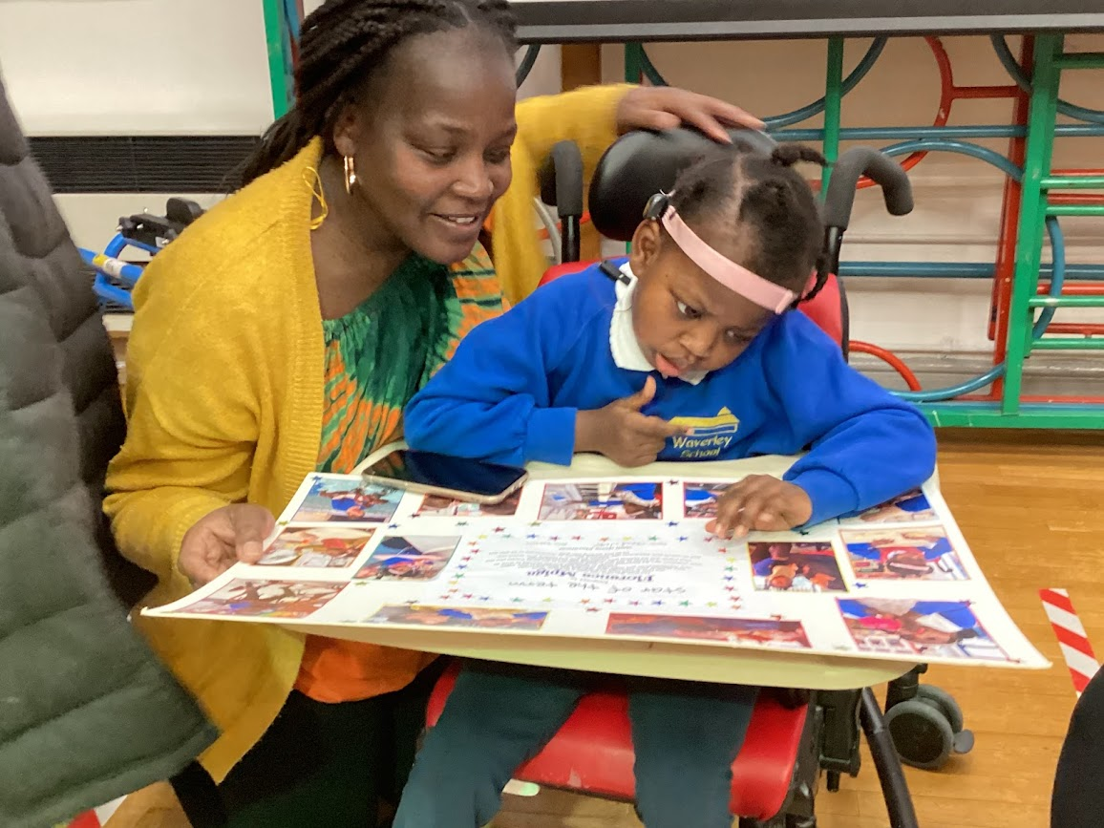
Thank you to the parents who attended the “star of the term assembly”. THis is a special assembly for pupils who have done especially well. The pupils really enjoyed being the centre of attention in the assembly.
Education Health and Care Plans We have noticed that many families need reminding of the date and time of the review. When we send you the date please make note of this appointment. We have 162 reviews to hold and it is often difficult to reschedule.
Strike Thank you for your patience and support for teachers during the industrial action. We recognise that closing classes has an impact on families. We try to keep as many classes open as we can.
Polio You may have seen the news that the polio virus has been detected in sewage samples in London last year. The NHS are contacting parents of children who are not fully vaccinated to sign consent for school-based vaccinations. Please look out for any communication from the NHS so you can book you vaccination if required.
Challenge Partners We have just hosted a number of senior leaders from other outstanding special schools. They reviewed our curriculum and assessment processes. Our Challenge Partners were really impressed with our staff's engagement with the children and young people and their commitment to the school and the families we support.

What did we get up to last term?
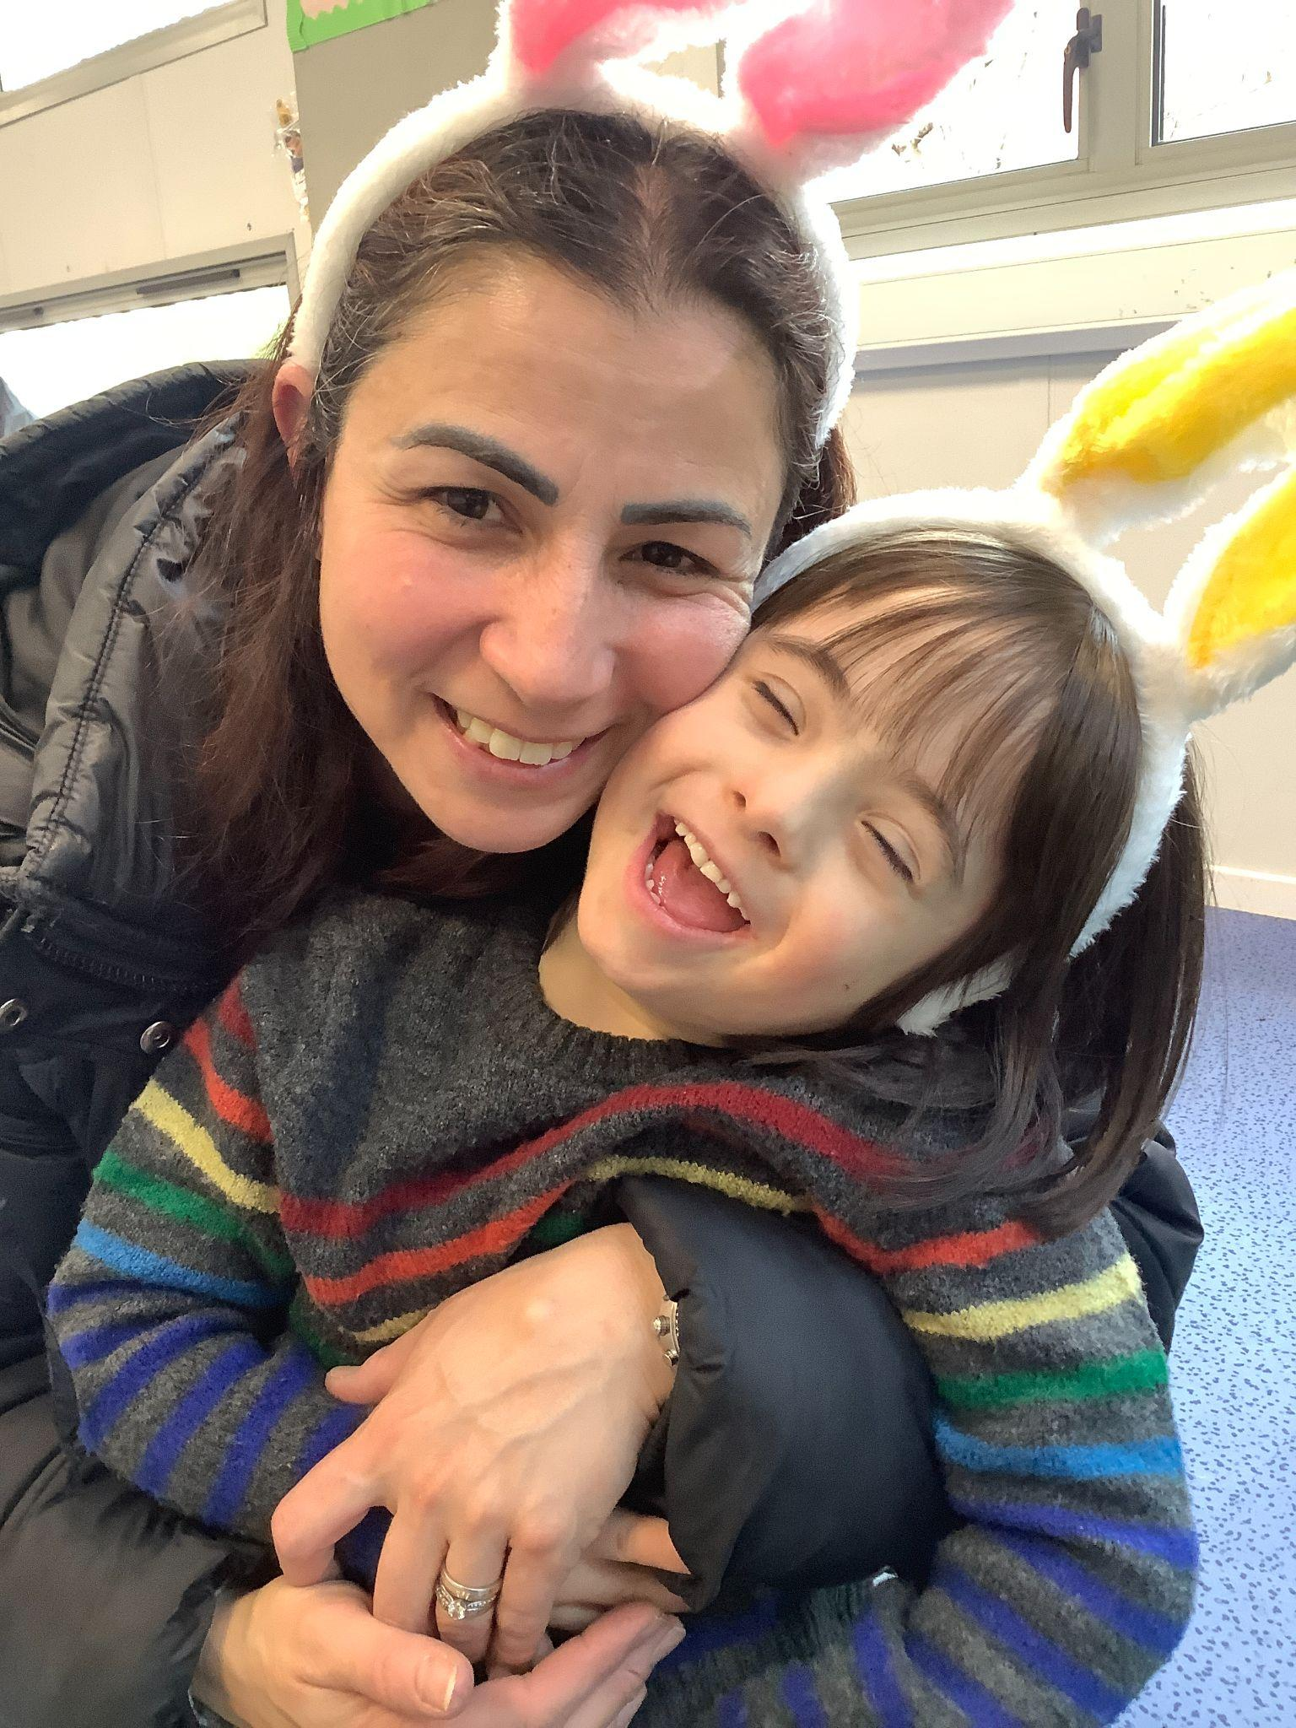
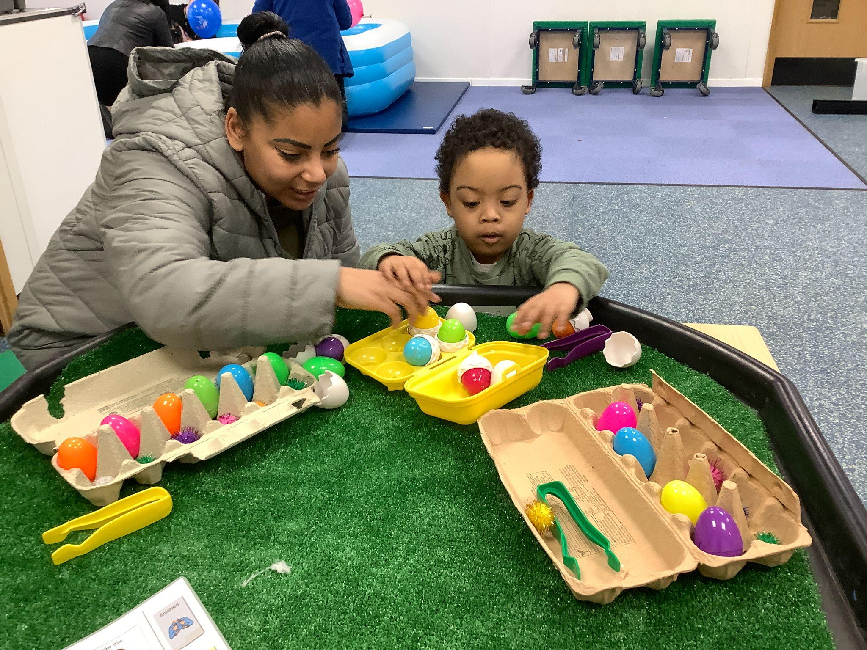
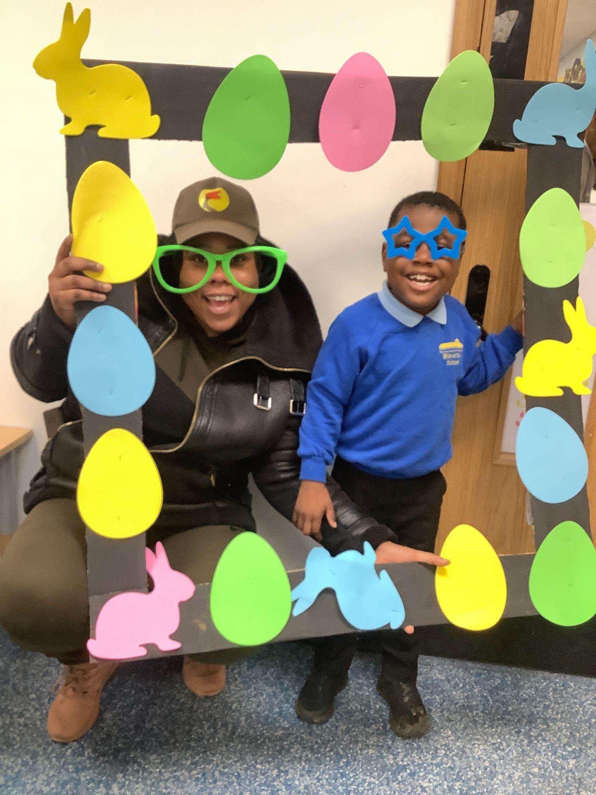
Waverley @ Honilands held an Easter event and invited parents in to join us. There were lots of activities and an Easter Egg hunt! Thank you to those parents who were able to join us.

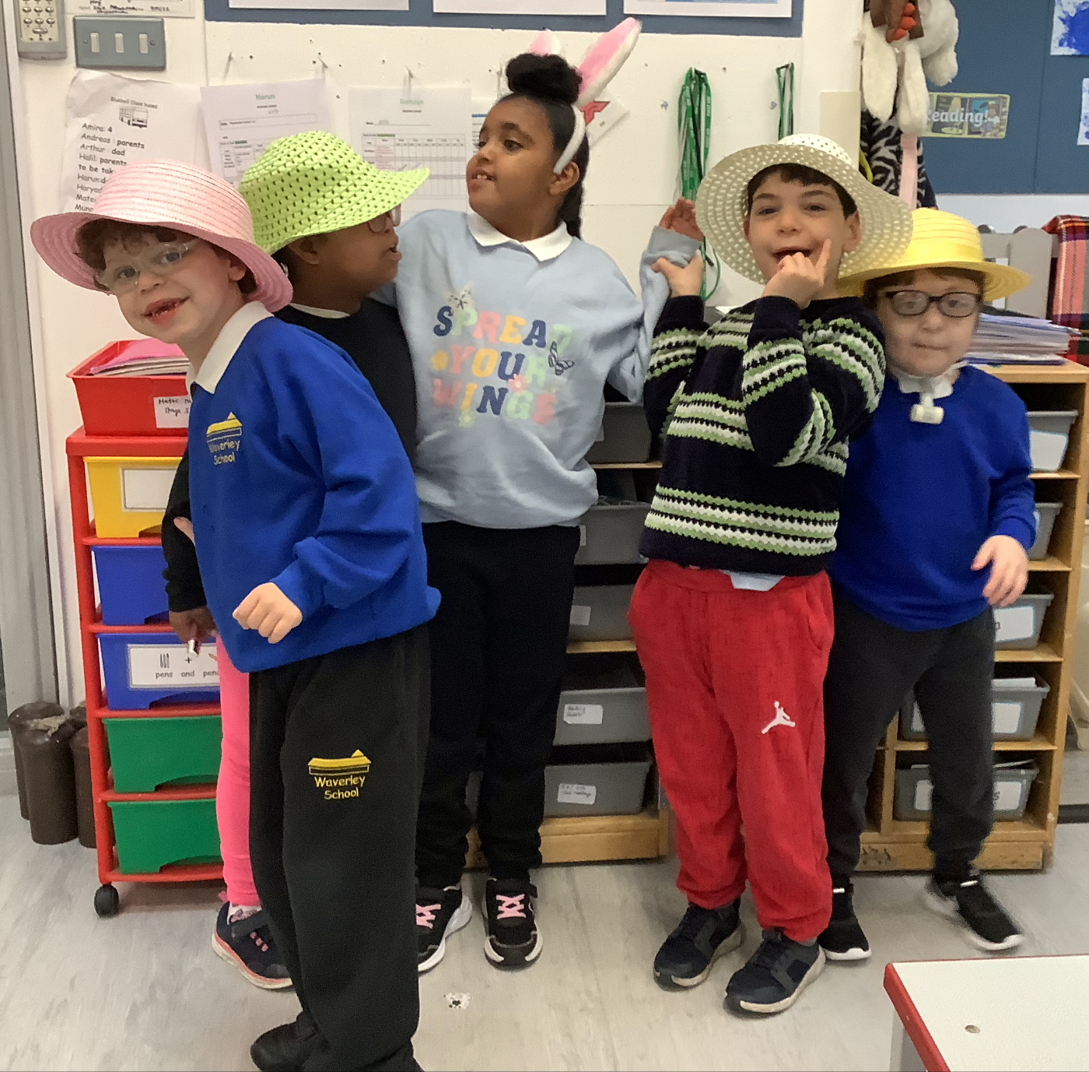
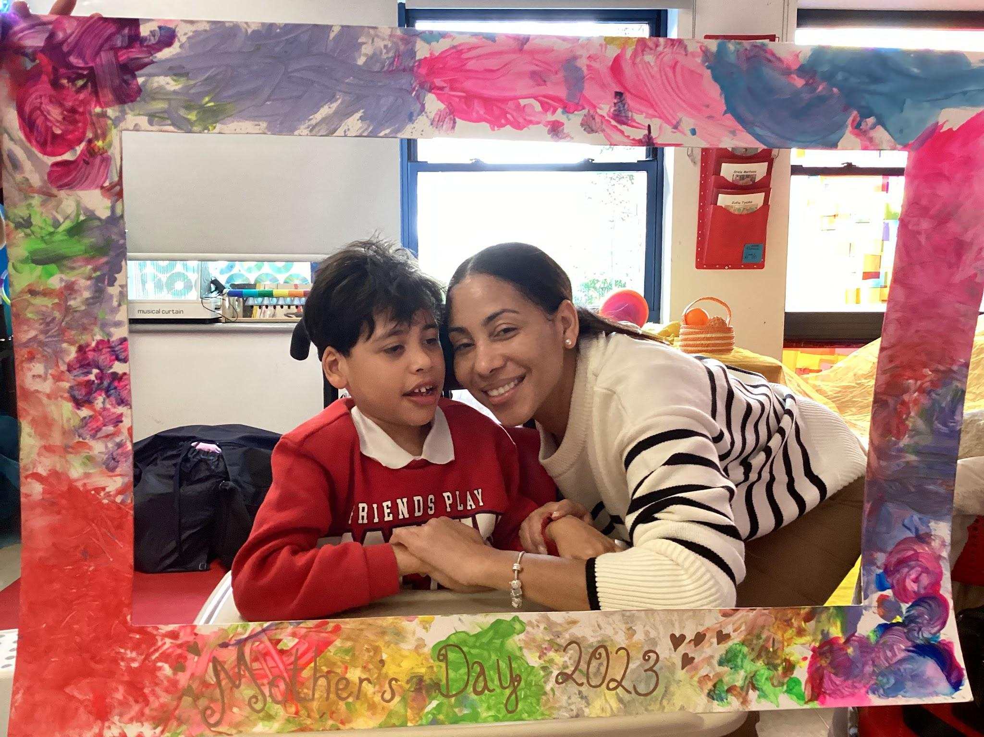
Primary 1 : Poppy class had a lovely mothers day celebration and invited mummies into school to have tea and cake. It is always lovely to see families in school.
Bluebell class look lovely in their Easter Bonnets

Primary 2 : Buttercup class represented the school at the dance festival. This is funded through the music hub.
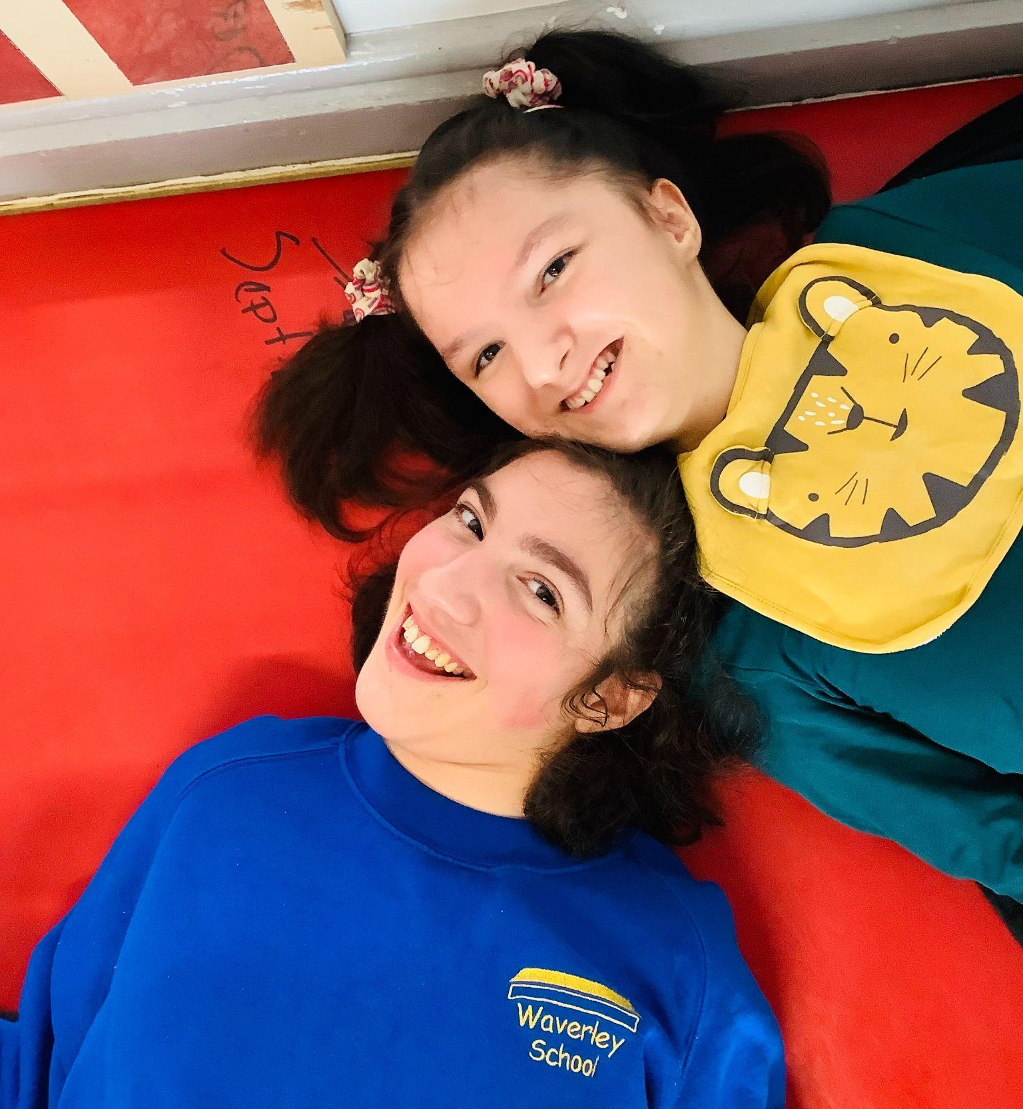
Secondary 3 : Cherry class Love making friends and posing for the camera !
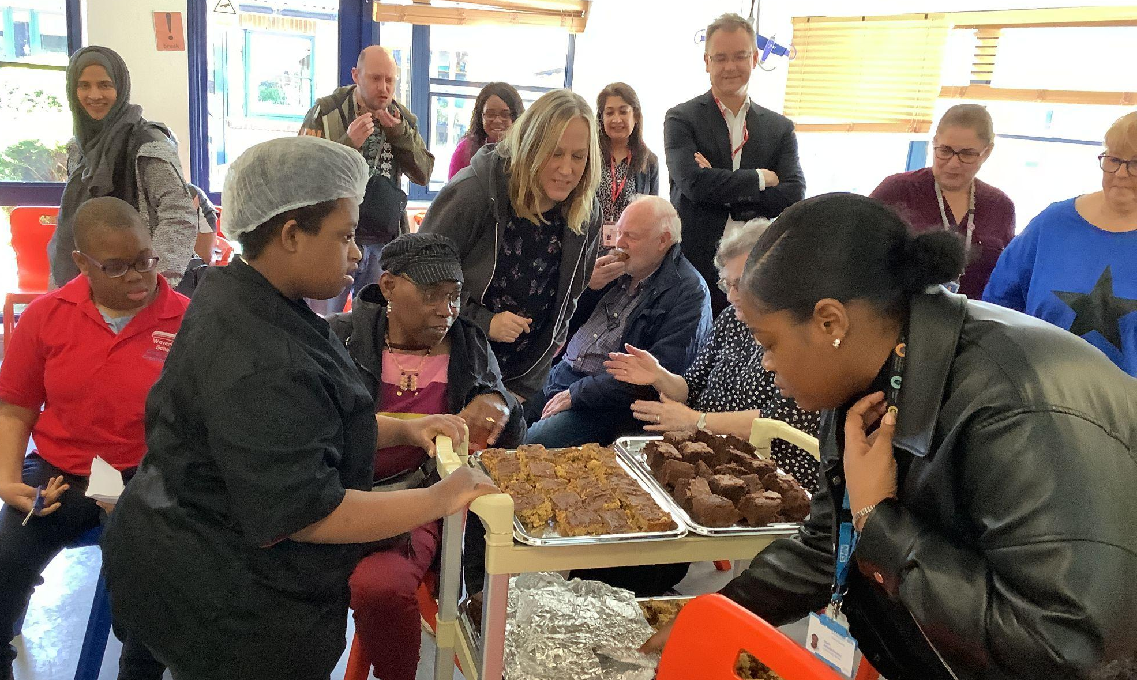
Secondary four held a wonderful open day to showcase their businesses. It was lovely to see so many parents and professionals from our feeder settings. The young people in Secondary four were able to demonstrate many of the new skills they have been working on. Each business presented to the audience. Our business are Crazy Crispy Creations Cafe, Funky Print (print studio), Bubble Warriors (cleaning enterprise), Scoop and Pour (refill shop.) Well Done everyone involved. Thank you to all the parents who attended the business launch : click on the link to find out more Secondary 4 businesses for website
The School Council has been meeting to discuss what they like about school and also what events they would like to organise for the school. They have all given us their views on what values they have, this is displayed outside the family room. So if you come into school take a moment to see what they have written. The school councillors all have their school council badges so that everyone knows who they are. We have councillors from each class on the mainsite.
Physical achievements : Girls football A group of girls presented the school, led by Gary Smith. It looks like they had a wonderful time. Check out our website for a film Gary has created.
The after school club has been really helpful for some families. The young people enjoy practising their skills.
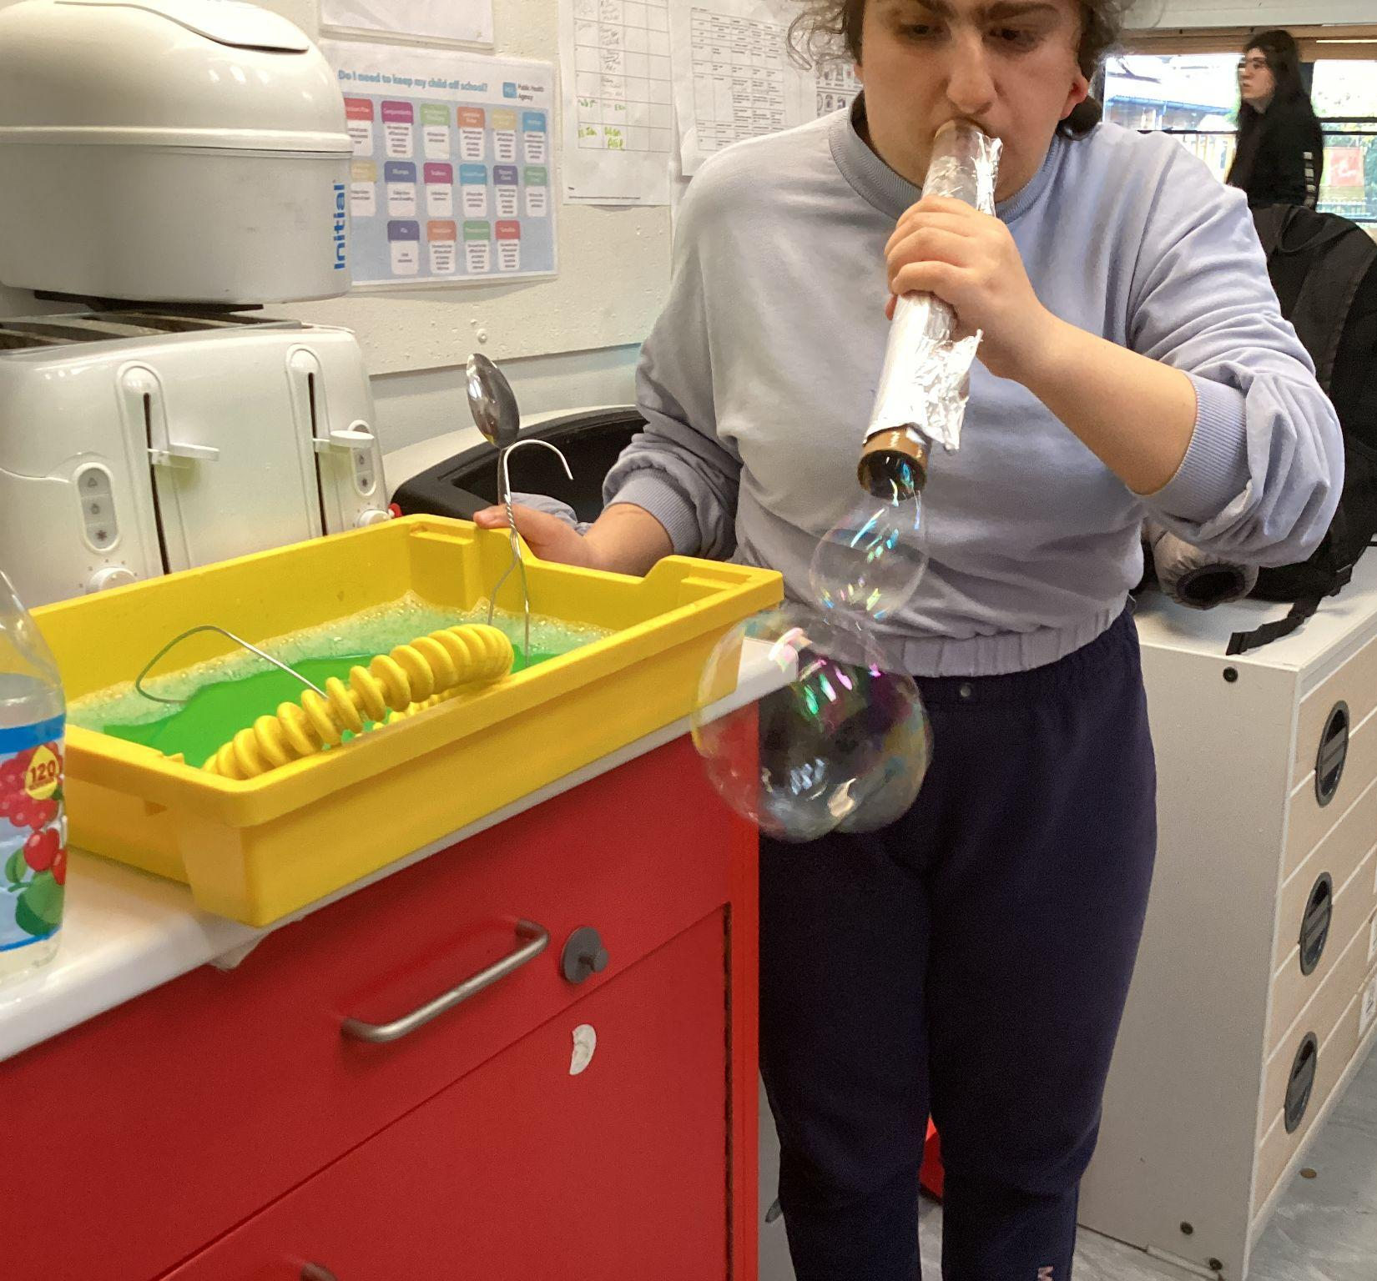
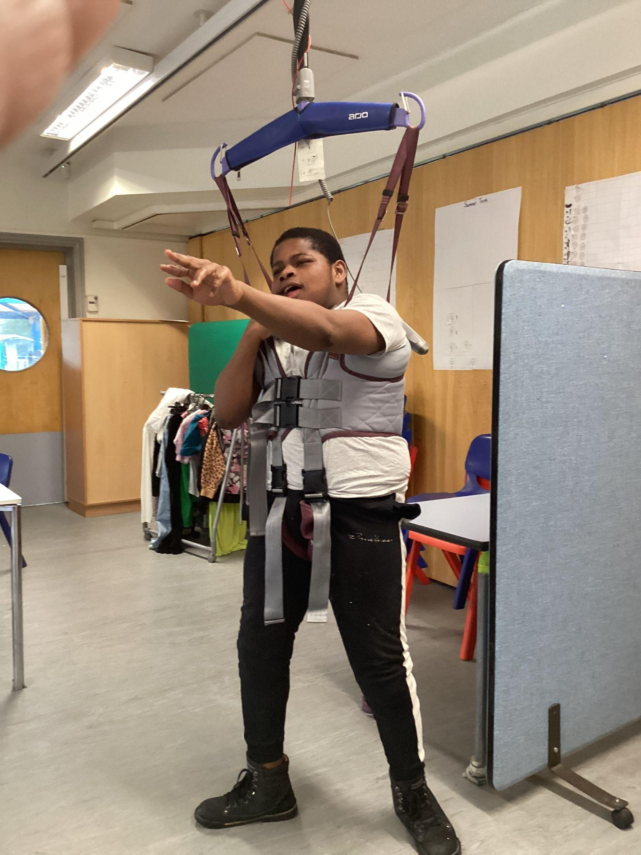

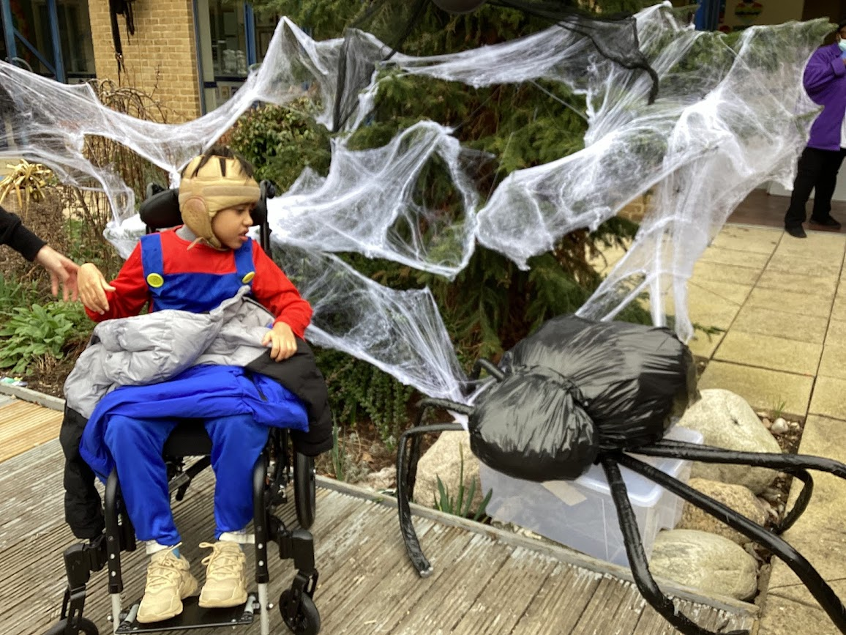
World Book day was a great success. The children and young people got to explore Harry Potter Land here at Waverley. You would not have recognised the school. Thank you to the parents who sent the children into school in outfits linked to books. As you know every child and young person needs opportunities to enjoy books and this is a great way to motivate our pupils. Thank you to the staff who put extra effort into the day to make it really special.
Can you spot the teachers?

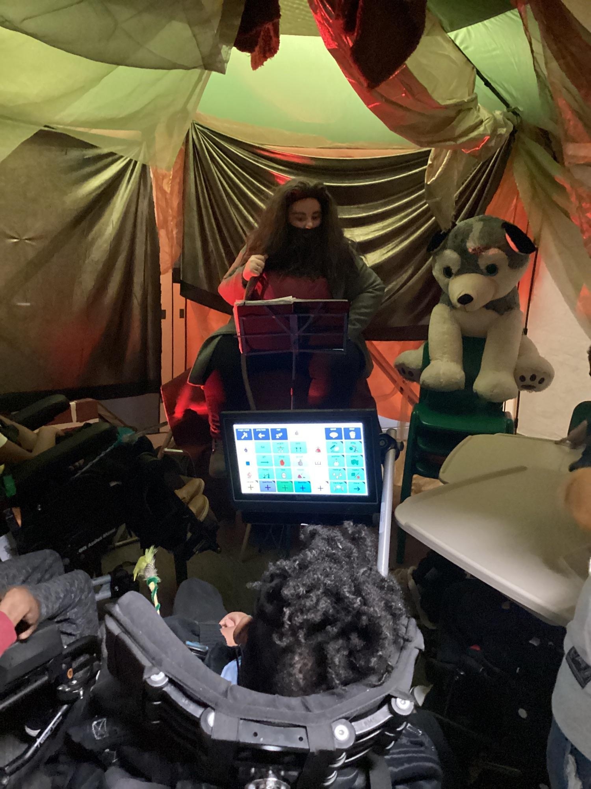
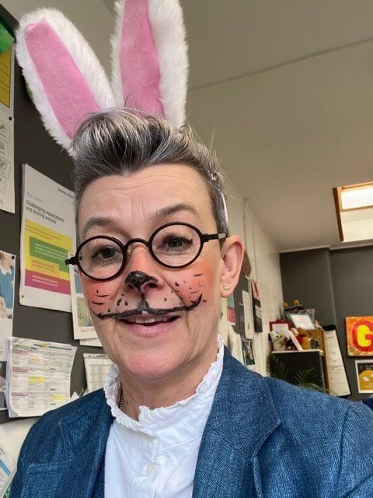

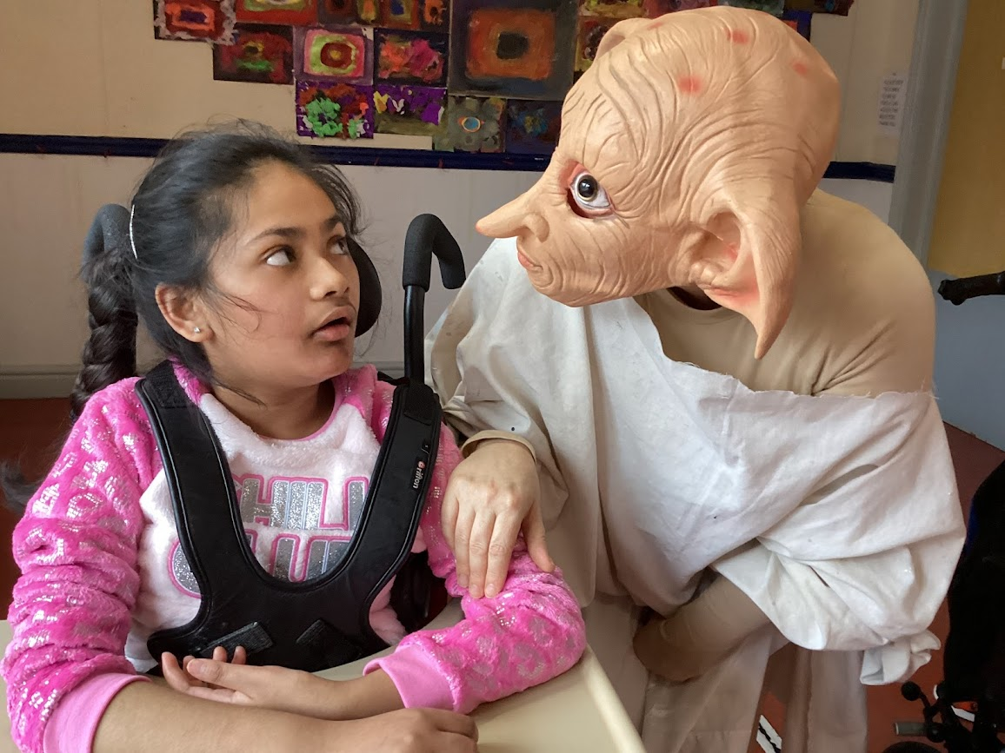
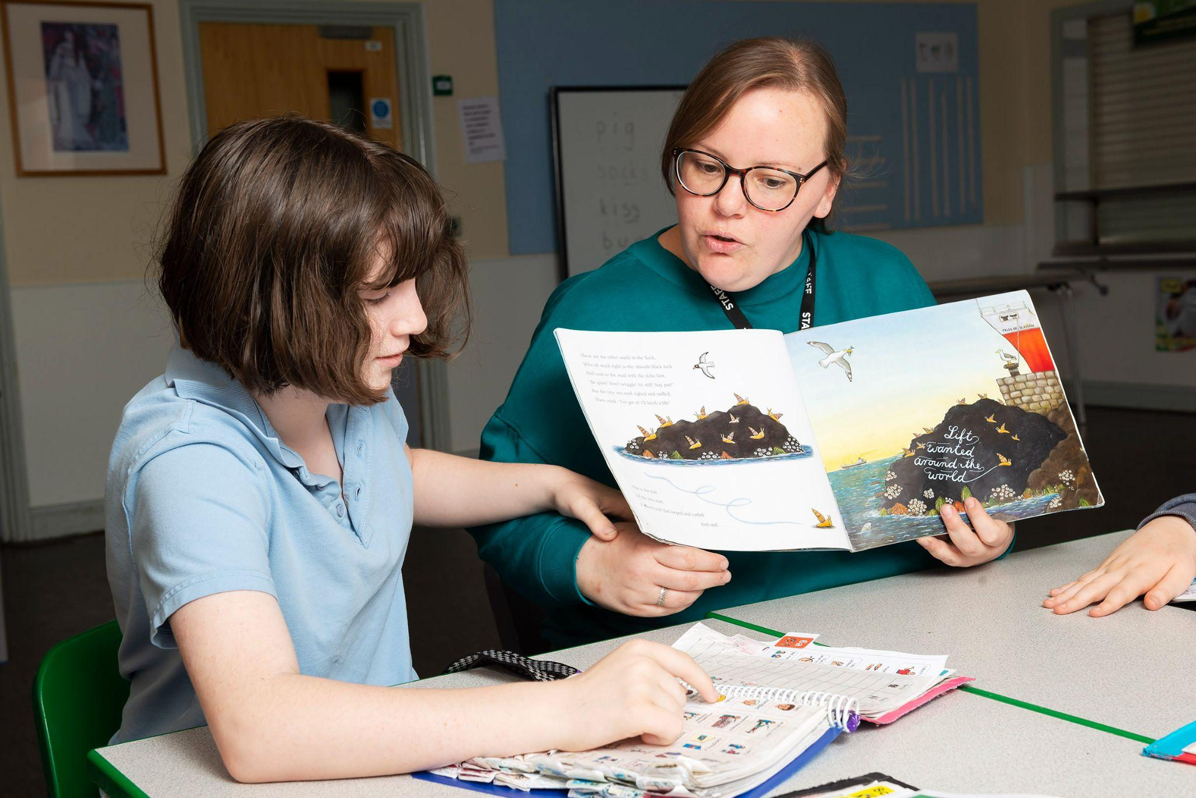

Parent survey: thank you to everyone who completed the parent survey. We had some wonderful feedback. I have shared your comments with the therapy leads so they can address any concerns raised through the survey. We also took note that many of you have really enjoyed using class dojo but some of you did not feel all teachers were reporting enough. All teachers should now be posting more regularly. Please do not sign up to a dojo subscription the free app will give you enough access.
Updates We have a new physio. Amy Solomon will be covering Sarah maternity leave. We wish Sarah well with the upcoming birth of her baby.
School improvement : pupil progress during the Spring term 2023
PUPIL PROGRESS - Whole School
Pupil progress target for 2022-23:
Almost all pupils make at least expected progress; only a very small number are judged to not be making the progress we would expect.

Progress last year (2021-2022):
Almost all pupils made at least expected progress in their learning, with almost a third making above expected progress.

Pupil progress 2022-23
Autumn Term
Most pupils made at least expected progress in their learning, with around a fifth making above expected. A minority of pupils were judged to be making below expected progress during the Autumn Term 2022.

Spring Term
Almost all pupils make at least expected progress in their learning, with around a quarter making above expected. A small number of pupils were judged to be making below expected progress during the Spring Term 2023. This number has reduced since the Autumn Term 2022.
The schools current priorities for the term
- We are supporting our leavers and helping with their transitions
- Planning classes for next year
- Finalising the budget
- Planning works for the summer
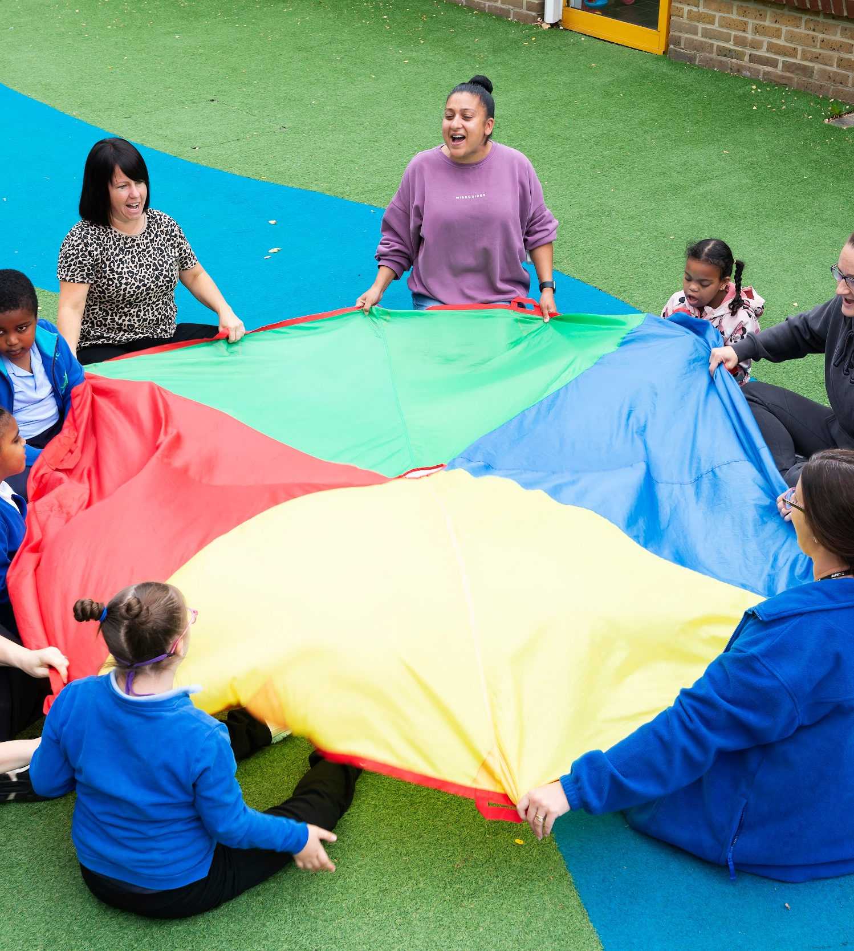
Resources with ever-shrinking budgets we are continuing to provide the children and young people with the necessary teaching equipment. Don’t forget to send in your termly donations for snacks and cooking ingredients etc £20 per term. If you are unable to contribute to this please ensure you send in your child’s snacks. Thank you to the families who have already provided this.
Parent Support: Sara Hassan will be able to support families who need advice. Please call her on Tuesdays between 9:30-2:30, her telephone number is 0208 941 9629 on Tuesdays.

Staff update: New staff
Cristina Di Marzio Yvonne Cusker Amy Solomon
Teaching Assistant School Nurse Physiotherapist
Thank you for you support:- Money raised; Easter egg raffle 2023 £393.00
School Dinners From the beginning of June we will be having a new catering company providing lunches. The lunches are costing school more than we previously paid. We will continue to subsidise the cost of the meals but we will have to increase the cost of the meals to £3.00 per meal. We may need to review this again in September. If you are entitled to free school meals and you have not informed us, please let us know.
These are the ways you can help support the school
Building trade
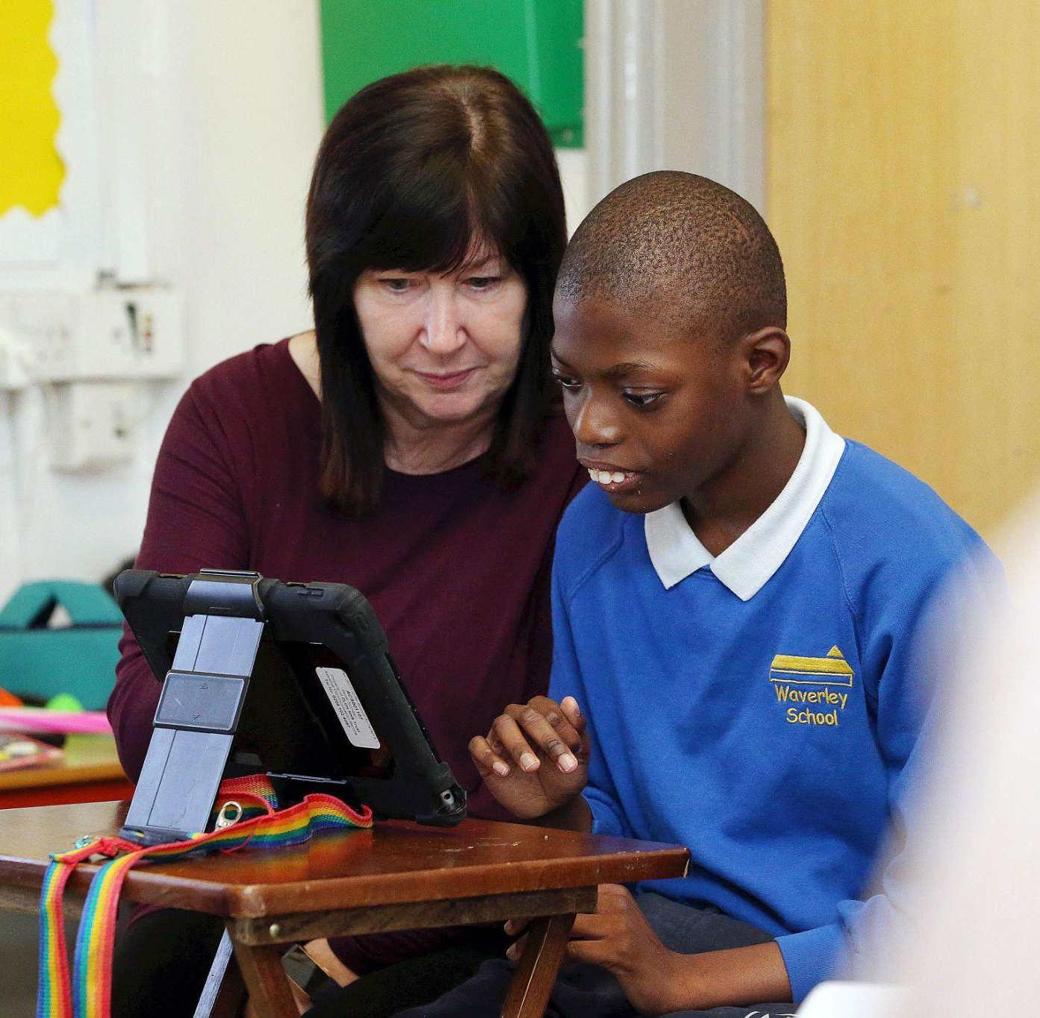
Budget: We would like to replace the kitchen cupboards in Primary 1 however our budget is restricting us. If you have any contacts in the building trade and who are in a position to support us we would be really grateful for making contact.
Ipads
We also want to replace many of our old ipads as they are now running too slow for the apps we need. If you are in contact with any businesses who would be able help us with this area of need, please get in touch.

Dates to remember;-
Monday 8th May 2023 - Additional bank holiday, closed to pupils
Monday 29th May 2023 - Friday 2nd June 2023 - May half term closed to pupils
Monday 5th June 2023 - pupils back to school
Monday 12th June Secondary sports day
Tuesday 13th June Paradise park trip Secondary 3
Wednesday 14th June Primary Sports day
Wednesday 5th July - Parents evening
Thursday 6th July - Leavers evening
Friday 21st July 2023 - Inset day closed to pupils
Monday & Tuesday 5th September 2023 - Pupils back to school

Waverley Association for Special People (WASP) - our School charity
If you have a fundraising idea or if you can help with the school lottery, payroll giving, easy fundraising, and match funding, please contact the school office on 0208 805 1858 and speak to Helene.
Or please Make a donation

Go fund me Easy fundraising Recycle with Michael School lottery

We have 37 supporters for the school lottery ! If you haven’t signed up yet for your school lottery, you are missing out. So
far there have been 203 winners, all friends of Waverley. Please click the link to join our school lottery. So far £5817.60 has
been raised.
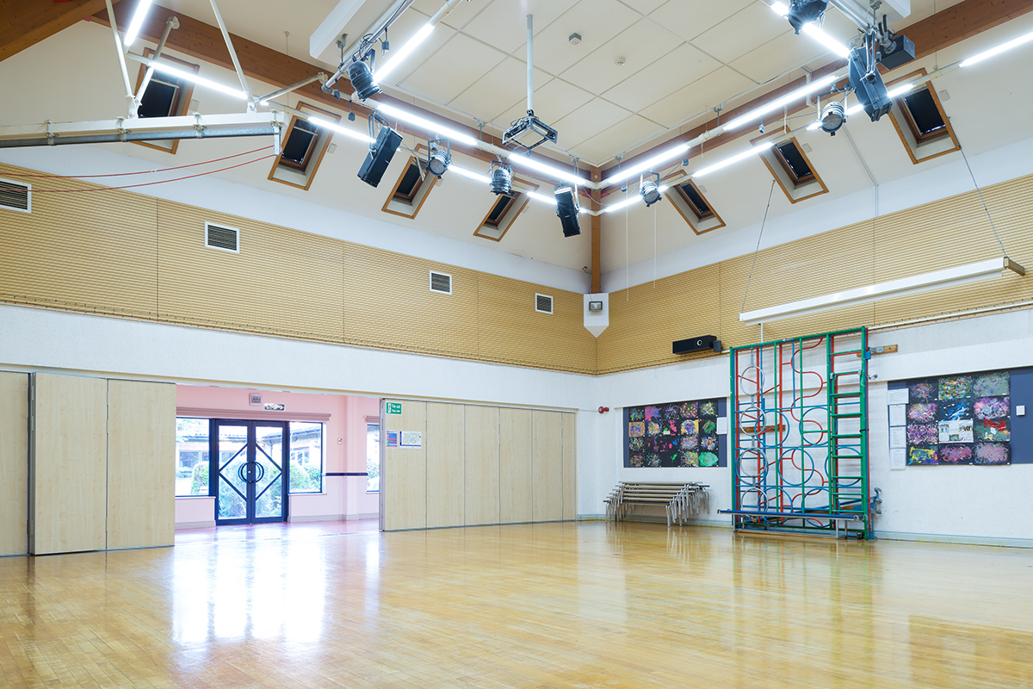
Waverley School premises for Hire
Waverley School is hiring out the school premises.
Please contact:- Jo Bukin: 07855 042 027
school.hire@yahoo.co.uk

